Vaccination Week in the Americas

20-27 APRIL
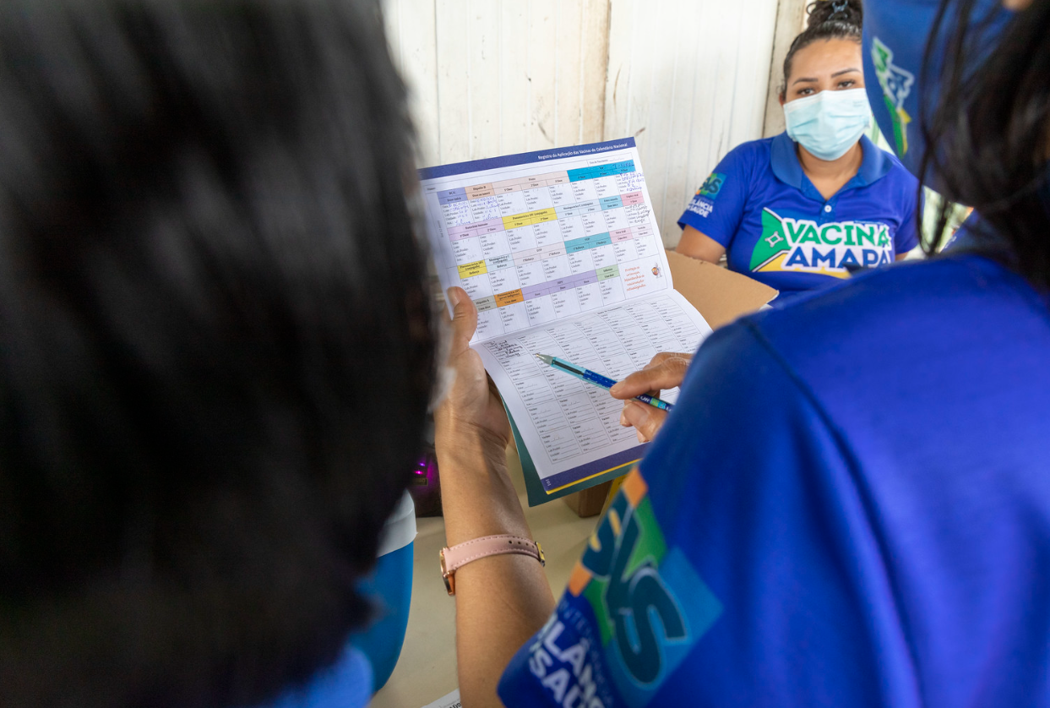
NATIONAL PLAN 2024
(Slogan will be communicated at a later date)

www.paho.org/vwa
PAHO/WHO
@pahowho
(insert name of country)

Vaccination Week in the Americas 2024
National Plan
Return to PAHO by 28 February 2024
Country Name
Summarize in a short paragraph how your country plans to celebrate VWA 2024.
Planned Launching Events
Date | Level (local, national, international, etc.) |  | Guests (ex., Government, UN agencies, civil society, celebrities) | Additional info

Campaign Specifics
Sustain the achievements  Indicate if your country will carry out activities to protect achievements (e.g.: maintain elimination of polio, measles, rubella, congenital rubella syndrome, neonatal tetanus; complete childhood schedules, etc.), and then briefly describe plans the space below | Yes  ☐ | No  ☐
Complete the unfinished agenda in order to prevent and control vaccine-preventable diseases  Indicate if your country will carry out activities to complete the unfinished agenda (e.g.: seasonal influenza prevention, protection of occupational risk groups, hepatitis B vaccination, etc.), and then briefly describe plans in the space below. | Yes  ☐ | No  ☐
Strengthen health services for effective vaccine administration  Indicate if your country will carry out activities to strengthen health services, including capacity building activities among health workers. | Yes  ☐ | No  ☐
Activities to promote vaccination among vulnerable groups  Indicate if your country will carry out activities to target vulnerable population groups (e.g.: indigenous groups; afro descendants, migrant) and then briefly describe the type of activities and the planned target groups in the space below. | Yes  ☐ | No  ☐
Activities to promote vaccination in low coverage areas  Indicate if your country will carry out activities to target unvaccinated and under vaccinated persons, briefly describe the type of activities and the planned target groups in the space below. | Yes  ☐ | No  ☐
Activities to promote PAHO’s Elimination Initiative  Indicate if your country will carry out activities to contribute to PAHO’s Elimination Initiative by targeting one or more of the 30 communicable diseases and related conditions identified by the Organization. Briefly describe the type of activities and the planned target groups in the space below. | Yes  ☐ | No  ☐

Goals by Population
Please enter the targeted number of persons that you aim to vaccinate per age group.
0-12 months | 1-4 years | 5-8 years | 9 to 18 years | Pregnant Women | Adults | >60 years | High risk occupations | Health Care Workers | Others | TOTAL
Comment/Explanation (if needed):

Goals by Antigen
Please enter the targeted number of persons that you aim to vaccinate with each antigen.
COVID-19 | Measles  Mumps Rubella (MMR) | Measles and Rubella (MR) | Polio bOPV | Polio  IPV | Yellow Fever | Influenza | Diphtheria, Tetanus, Pertussis (DTP) | Diphtheria Tetanus  (<7 yrs.)  (DT)
Tetanus diphtheria (>7 yrs.)  (Td) | Haemophilus influenzae type b  (Hib) | Hepatitis B | Penta-valent | BCG | Rotavirus | Pneumococcus | HPV | Other (Varicella, Cholera, Meningococcal, Hep. A, etc.)
Comment/Explanation (if needed):

Goals by unvaccinated / under vaccinated children younger than 5
Estimated total number of unvaccinated* children at country level  *Children younger than 5 who did not receive the first dose of the vaccine against diphtheria, tetanus, pertussis (DTP1) | Please enter the estimate number of unvaccinated* children you plan on reaching  *Children younger than 5 who did not receive the first dose of the vaccine against diphtheria, tetanus, pertussis (DTP1)
Estimated total number of undervaccinated* children at country level  *Undervaccinated children are those who have not received all recommended vaccine doses according to their age group/country of residence. | Please enter the estimate number of undervaccinated* clidren you plan on reaching  *Undervaccinated children are those who have not received all recommended vaccine doses according to their age group/country of residence.

COVID-19 Vaccination
VWA 2024 will give countries a platform to continue promoting COVID-19 vaccines and close immunity gaps.
Will your country use VWA 2024 to vaccinate people against COVID-19? |  |  |  |  |  |  | Yes  ☐ | No  ☐
Number of people expected to be vaccinated against COVID-19
Health workers | Pregnant women | Adults  aged 60 years or older | People with underlying health conditions | Healthy adults aged 18 or older | Healthy children/adolescents aged 6 months to 17 years | Total

Seasonal Flu Vaccination
VWA 2024 will focus on prioritizing influenza vaccination to prevent respiratory illness or hospitalizations caused by influenza in countries where the influenza season will begin.
Indicate whether your country will prioritize influenza vaccination, which methods will be used to reach the population, which groups will you prioritize and how many people are you planning on vaccinating. |  |  |  |  |  |  | Yes  ☐ | No  ☐
Comment/Explanation (if needed):

Number of people expected to be vaccinated against influenza
Children younger than 5 years | Pregnant Women | Individuals with chronic diseases | Adults  aged 60 years or older | Health workers | Others | Total

Polio Vaccination
VWA 2024 will focus on prioritizing polio vaccination to protect against cVDPV2 tranmission, the importation of cVDPV2 and WPV1, and contribute towards the global eradication goal.
Indicate whether your country will prioritize polio vaccination, which methods will be used to reach the population, which groups will you prioritize and how many people are you planning on vaccinating. |  | Yes  ☐ | No  ☐
Comment/Explanation (if needed):

Number of people expected to be vaccinated with bOPV
Children younger than 5 years | Children aged 5 years or older
Number of people expected to be vaccinated with IPV
Children younger than 5 years | Children aged 5 years or older

Measles Vaccination
The history of VWA dates to a 2002 proposal by the Ministers of Health of the Andean Region, following the last indigenous measles outbreak in the Americas. This proposal called for a coordinated vaccination effort across national borders to reach vulnerable populations, put an end to the outbreak, and prevent future outbreaks. Today, the Region of the Americas is facing new measles outbreaks, after having been declared free of this disease in 2016.

VWA 2024 is a great opportunity for all the countries of the Region to do their part to protect their communities, close the gaps in access, coverage and reach to measles vaccines and permanently eliminate the measles virus in the Americas.For countries looking to further elaborate on catch-up operations related to MMR vaccination, please see Annex A.

Protect the achievement of measles elimination  Check yes or no to indicate if your country will carry out activities to protect the elimination of measles in your country. Describe activities below. |  | Yes  ☐ | No  ☐
Number of children expected to be vaccinated against measles
Age range
Will adults be vaccinated against measles? | Yes ☐ No ☐
Number of adults expected to be vaccinated against measles

HPV Vaccination
VWA 2024 is a great opportunity for countries of the Region that introduced HPV vaccines into their schedule to reach adolescents, close gaps and improve coverage rates.
Improve HPV vaccine coverage rate  Check yes or no to indicate if your country will carry out activities to improve HPV Vaccine coverage in your country. Describe activities below. |  | Yes  ☐ | No  ☐
Number of adolescent girls expected to be vaccinated against HPV
Age range
Number of adolescent boys expected to be vaccinated against HPV
Age range

Social mobilization and communication activities
Will your country use the theme “Vaccines as part of an active life” | Yes  ☐ | No  ☐
Will your country develop other targeted messages/slogans? These can include the adaptation of slogans into indigenous languages. Describe below. | Yes  ☐ | No  ☐
Will your country develop additional communicational/promotional materials (e.g., brochures, posters, t-shirts)? Describe below. | Yes  ☐ | No  ☐
Will your country carry out activities to improve public awareness and health literacy regarding the importance of immunization and vaccines? (e.g., webinars, forums, videos, other public awareness activities). Describe below. | Yes  ☐ | No  ☐
Will there be press releases to promote media coverage? Indicate if you will use/adapt the regional press note or prepare your own. Describe below. | Yes  ☐ | No  ☐
Will social media (Facebook/Twitter/Instagram) be used to promote VWA in your country? Indicate the accounts that will be used to share messages. Describe below. | Yes  ☐ | No  ☐
Will there be documentation of activities through photos, videos and/or other audiovisual materials? | Yes  ☐ | No  ☐
PS. In the final report, we will request links to press coverage, JPGs or links of photos, and any video footage. Please make sure you collect written approval from individuals featured in these media.

Risk Communications and Community Engagement
Are you using VWA to promote messages on the following topics?
1) Safety of vaccines | Yes  ☐ | No  ☐
2) Effectiveness of vaccines | Yes  ☐ | No  ☐
Are you engaging in any social listening activities to monitor and address rumors and doubts about immunization? Please list/describe below: | Yes  ☐ | No  ☐
Are you training health care workers on interpersonal communication, including how to respond to rumors and doubts about immunization? Please describe below: | Yes  ☐ | No  ☐
Are you using the events of the VWA to engage key stakeholders on immunization, including at the community level? Please describe below. (e.g., collaboration with civil society organizations, religious leaders, professional and patient associations) | Yes  ☐ | No  ☐

Integrated activities
Will your country involve integrated interventions (non-vaccination related) during VWA? (e.g.: Vitamin A supplement, Deworming, , health screening, and health education). Please describe below the type of activity and targeted audience. | Yes  ☐ | No  ☐

Evaluation activities
Countries are highly encouraged to undertake short surveys during VWA. A proposed template can be found on the website (see direct link below), followed by a model survey for evaluating VWA social communication campaigns (see direct link below).
Will your country do any evaluation activities for VWA? (e.g.: administration coverage, assessment of public satisfaction with vaccination, vaccine confidence, evaluation of VWA social communication campaigns, targeted coverage surveys). Describe below | Yes  ☐ | No  ☐

Annexes
Please attach any additional information you would like to share.

Annex A
Further information on MMR catch-up vaccination activities being planned
VWA 2024 is an opportune time for the countries to focus on reducing children susceptible to Measles, Mumps and Rubella. This annex can assist countries to track and judiciously update cohorts with regards to this susceptible children.

Please enter in this table the number of planned catch-up doses for MMR1 and MMR2 that your country plans on administering by birth cohort.
Year of Birth | 2017 | 2018 | 2019 | 2020 | 2021 | 2022 | 2023
Planned doses of MMR2 to be administered
Planned doses of MMR1 to be administered

